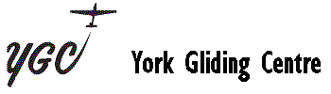
2025 Course Booking Form
Dates are: 19 May – 23 May, 28 July – 1 August, 8 September – 12 September
Course Start Date
Name
Address

Telephone Home
Mobile
Work
Email
Previous Experience
Please send the completed form to Graeme Alexander (email address below) and your deposit of £100.00 to the office, which includes your course fee of £50.00 (non-refundable) and £10 per day temporary membership (payable in advance) if you are not already a member. This will then confirm your booking.

York Gliding Centre Ltd.
Rufforth
York
YO23 3NA
01904 738694
gcalexander@mail.com

